**CSA1539 – THEORY OF COMPUTATION WITH MODEL**

**(SIMULATIONS)**

1. Design DFA to accept bcaaaaaaaaaaaaaa, bc, and c

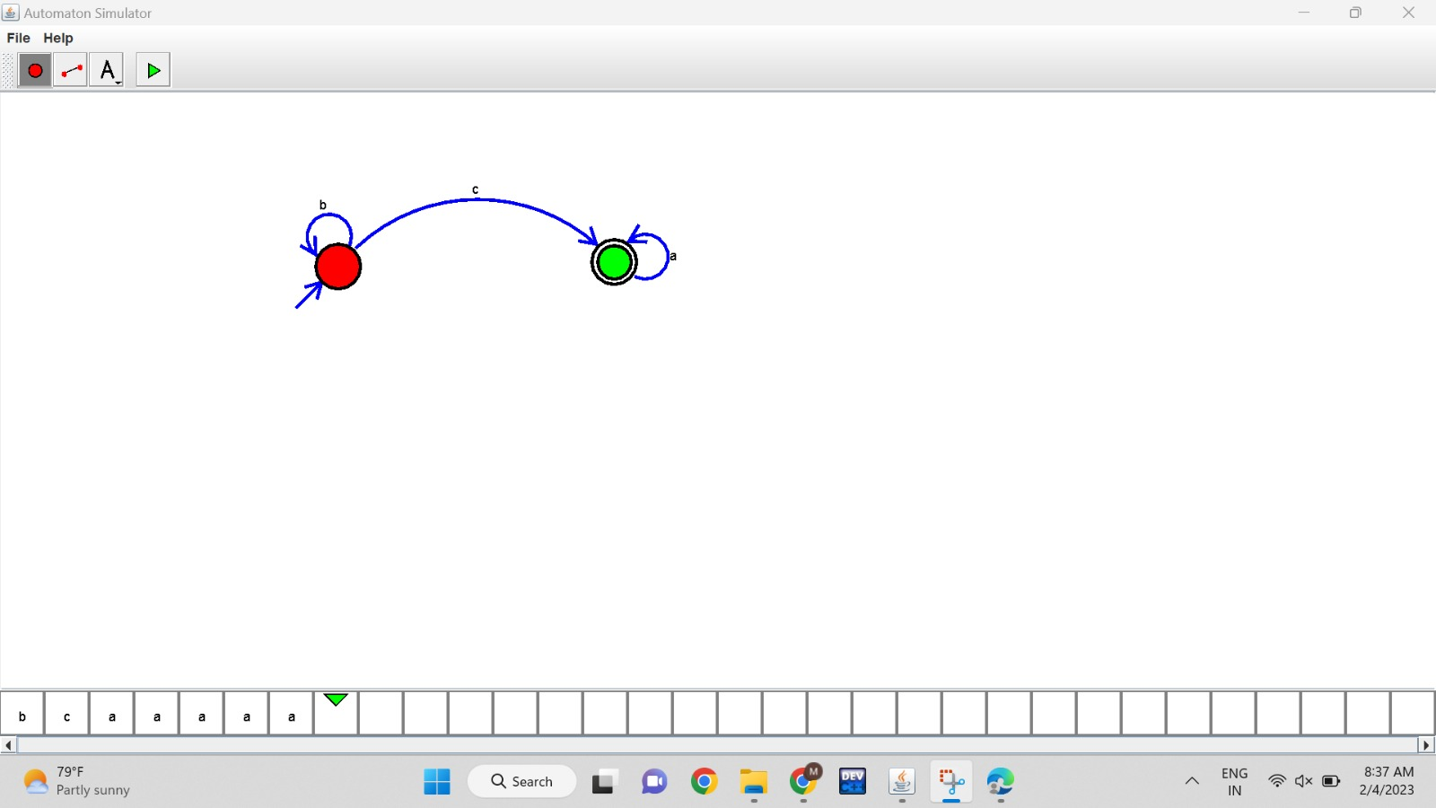

1. Design NFA to accept aaaaaa

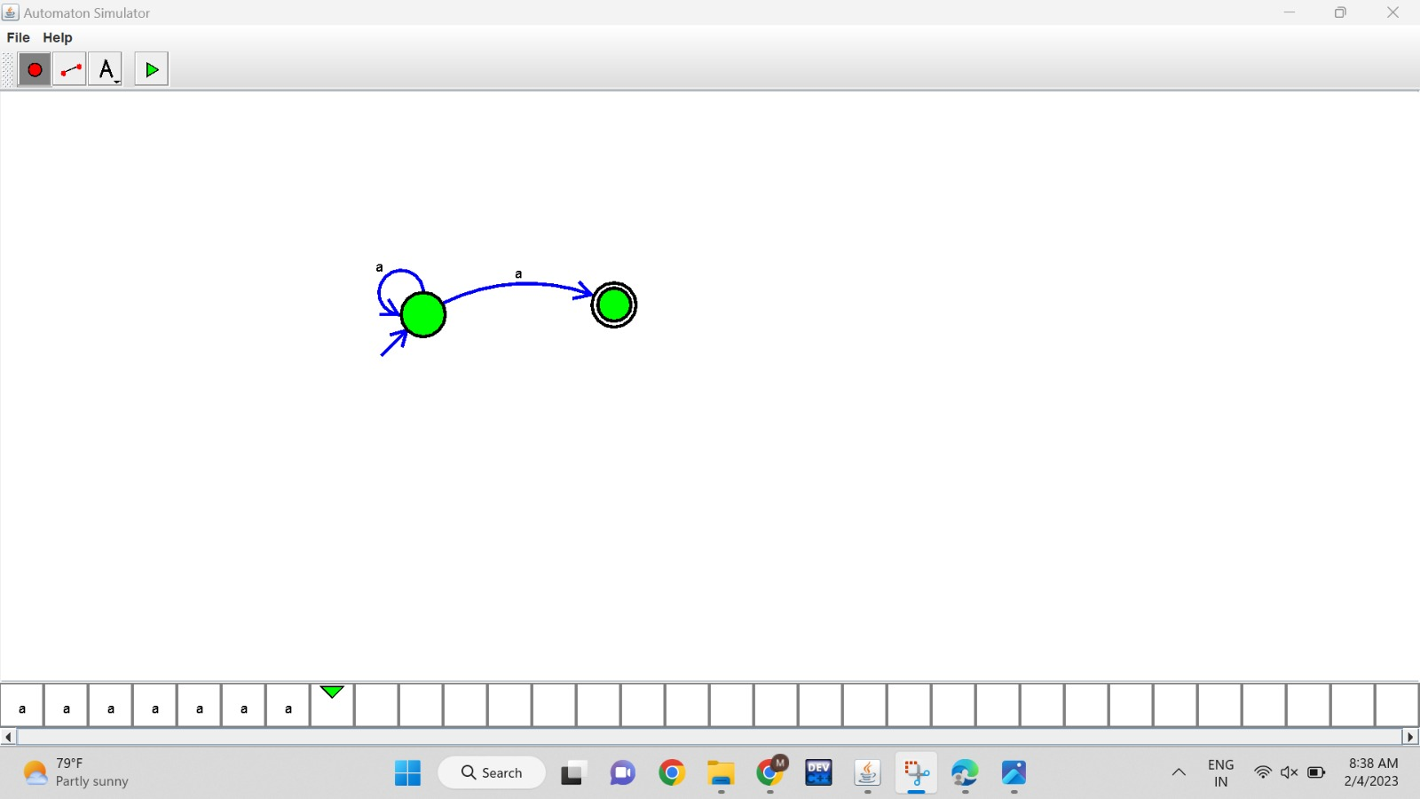

3.Design PDA for the input a^nb^n

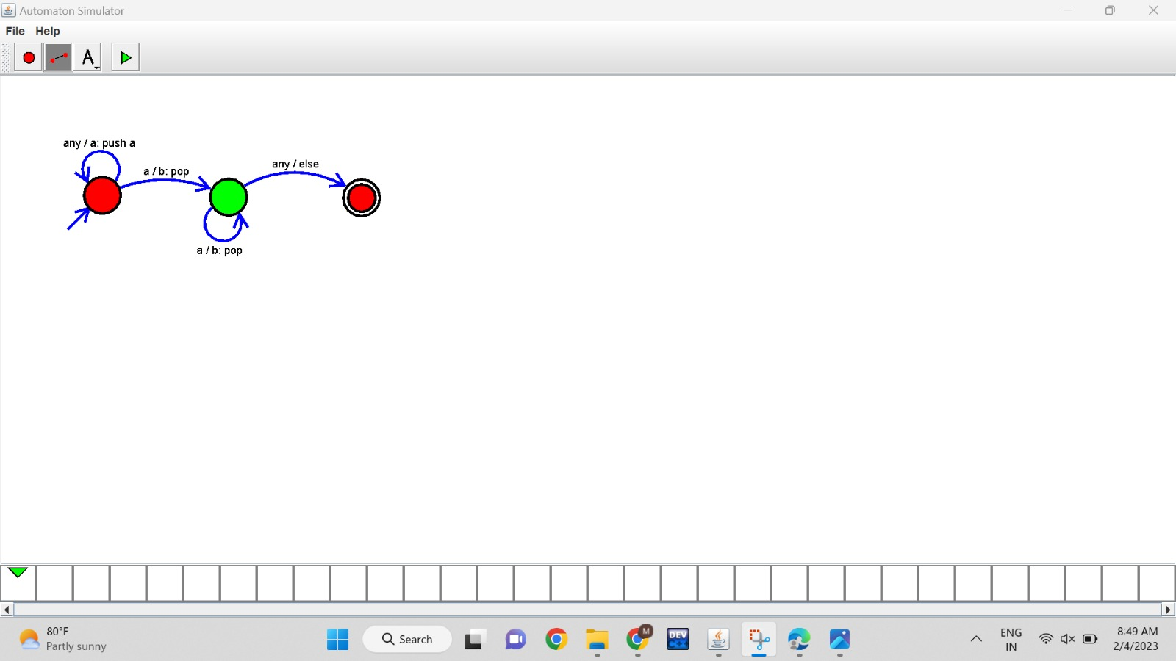

4.Design Tm For input a^nb^n

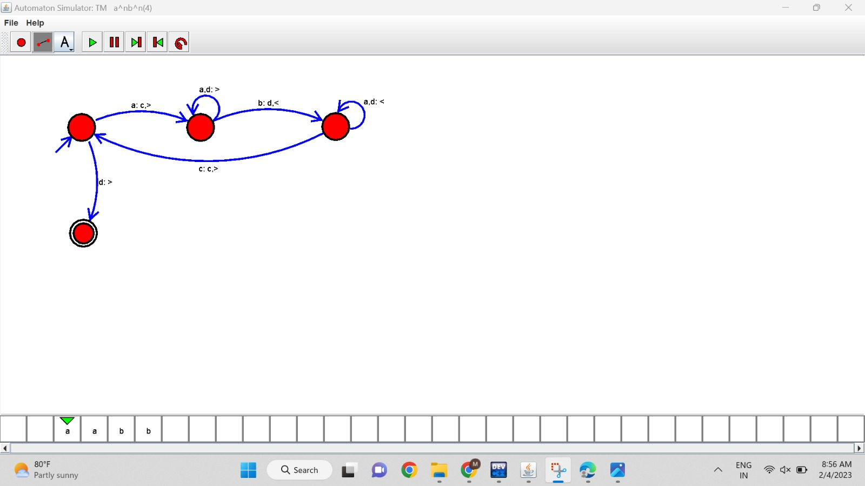

5 .Design PDA for input aabbbbc (L=a^nb^2n)

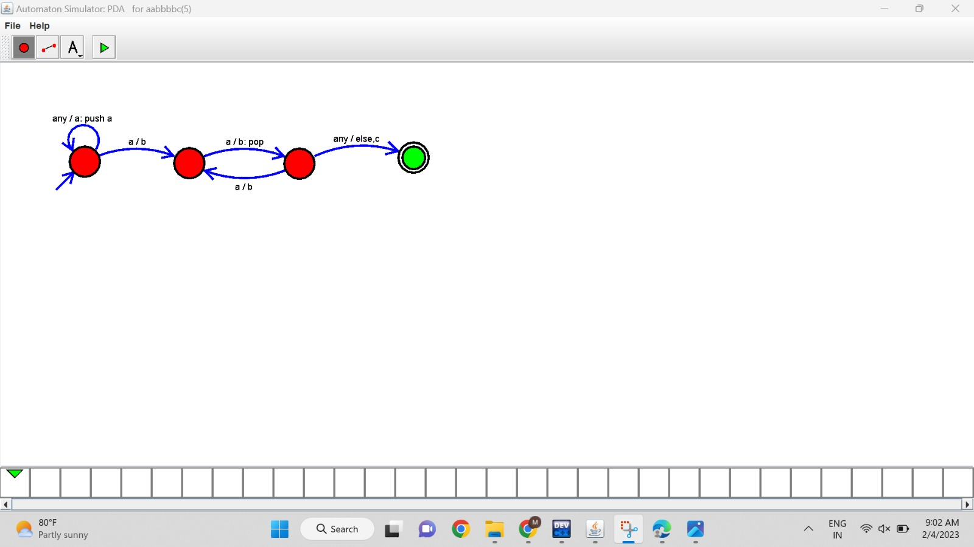

6.TM Simulation for Palindrome W= ababa c

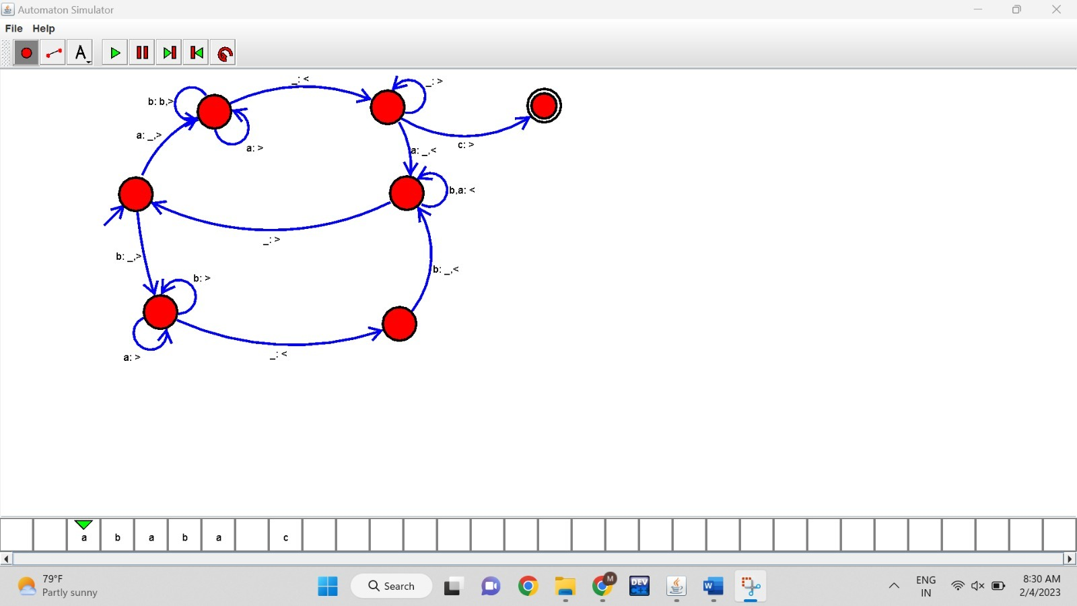

7.Design TM to perform addition of following

W= aa + aaaa

After Addition of a’s = aaaaaa

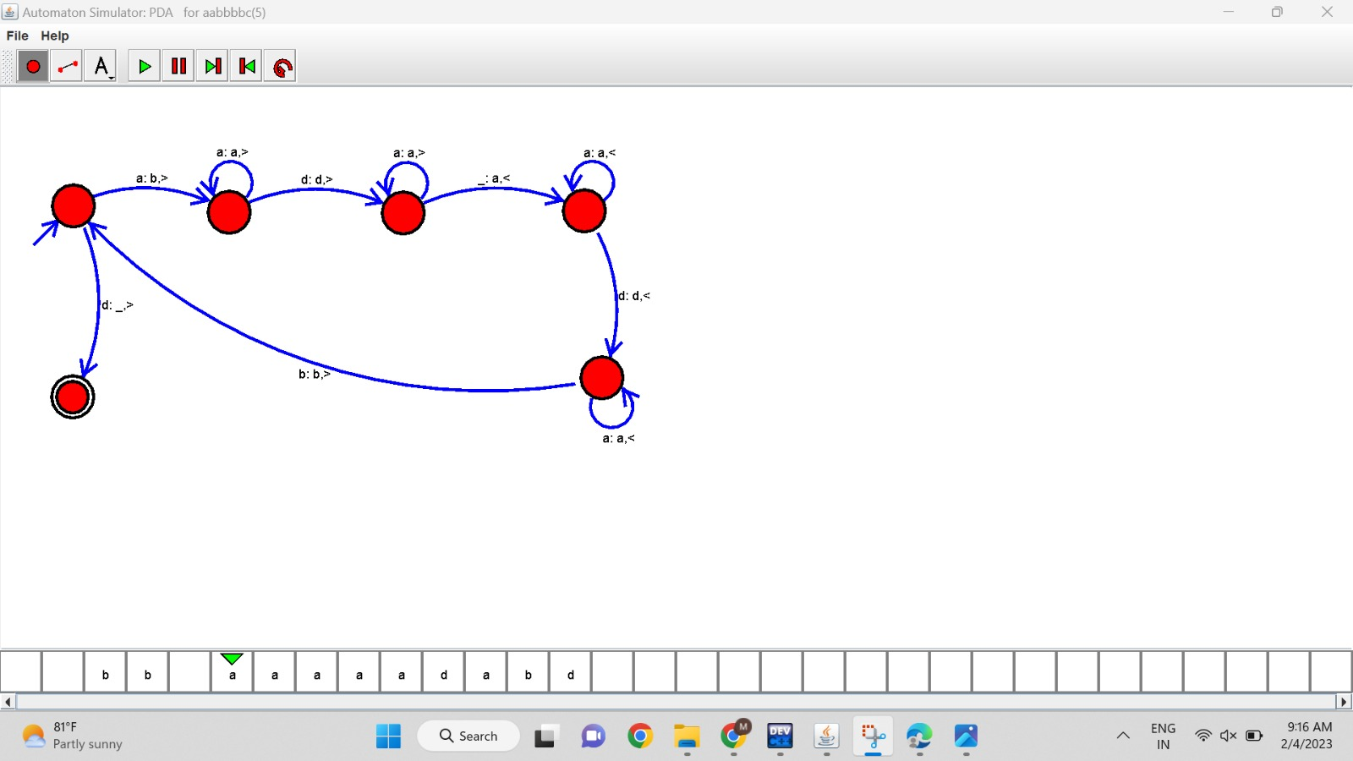

8.Design TM to perform subtraction

W= aaa-aa

The Result of Subtraction is = a

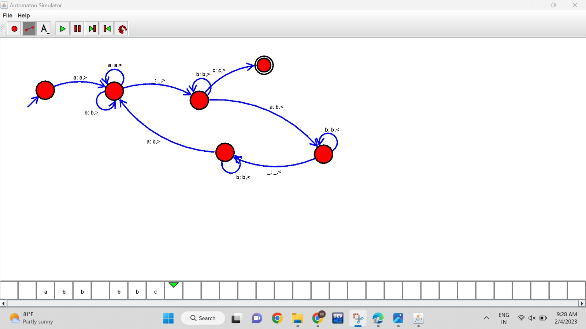

9.Design TM to perform string comparison

W = aba aba

